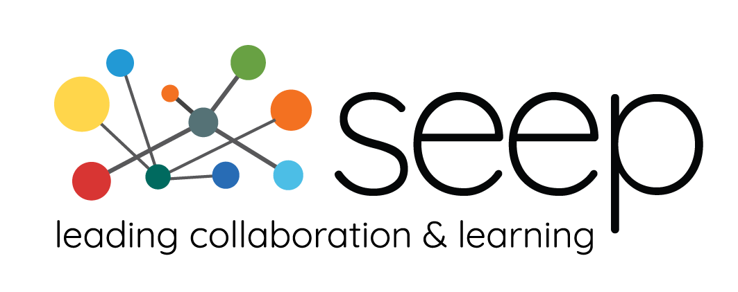

WS4R Innovation Fund Application

SEEP is delighted to launch a challenge fund to support innovations in gender intentional COVID response and recovery efforts related to Savings Groups. Successful projects will improve the resilience of Savings Groups and their members in times of crisis and the capacity of sector stakeholders to engage them in emergency response efforts.
The fund will be responsive to promising innovations of diverse types and scope. This may include communications and training materials, program models, policy development, technology, or new partnerships and disruptive collaboration.
We're excited to read about your proposed innovation! Before you start your application, make sure to review the WS4R Innovation Fund description and selection criteria.
Required fields: Required fields are indicated with a red asterisk.* Partially completed applications cannot be saved. You must complete all required fields in order to submit the application.
This Word version of the application form is available for reference. Kindly note that all applications must be submitted through the online application form.
If you have any questions, please contact us at SavingsGroups@seepnetwork.org.

Your Organization
Organization Name*
Please select the type you feel best represents your organization’s work: *
- Academic/Research
- Association/Network
- Funder/Foundation/Multilateral donor
- Government/Public Sector Agency
- Independent Development Practitioner/Consultant
- NGO/Capacity Development Organization
- Private Sector/Commercial
Address*
Website*

Primary Contact
First Name*
Last Name*
Title*
Email Address*
Phone*

Secondary Contact
First Name*
Last Name*
Title*
Email Address*
Phone*

- THE PROBLEM
What is the problem to be resolved or the condition to be improved?*
(Maximum 500 words)

Which dimension(s) of the COVID pandemic’s effects on women does the proposed innovation address? Please select all applicable dimensions:*
- Health (E.g. reduced access to reproductive health care, increase in intimate partner violence, increased anxiety and symptoms of depression)
- Economic (E.g. disproportionate decrease in employment and income, increased burden for unpaid work)
- Social (E.g. disproportionate impact of containment measures, decreased social interactions)
- Other (Please specify):

- THE CONTEXT

Please provide a detailed description of your work with Savings Groups and how it has been impacted by COVID. In this context, what are the main constraints and enablers of women’s empowerment?
Please include references to the evidence you rely on for your analysis. *
(Maximum 750 words)

- THE SOLUTION

What's your proposed solution? How does it address the problem identified above? How does it contribute to the expected outcomes of the WS4R Innovation Fund?
- Expanded body of knowledge, tools, or institutional capacity for gender intentional COVID response and recovery efforts related to Savings Groups in Africa.
- Improved capacity of Savings Groups – and COVID response and recovery efforts – to meet the needs of women in targeted populations in Africa – along health, economic and social dimensions. *
(Maximum 750 words)

How is this solution innovative? What gaps – in evidence, capacity, policies or tools – will it help to address? *
(Maximum 300 words)

What potential is there to scale the innovation following project completion? How might the innovation be replicated in other contexts and geographies? *
(Maximum 300 words)

- ORGANIZATIONAL EXPERIENCE
Please summarize your organizational experience in working with Savings Groups and implementing gender intentional or gender transformative interventions related to economic empowerment, justice and rights. *
(Maximum 500 words)

How will you integrate a gender lens into the design and implementation of the proposed innovation? *
(Maximum 500 words)

- START AND END DATES
Start date: March 1, 2021*
End date (no later than August 31. 2022):

- GEOGRAPHY SERVED
Country/Countries: *
For each country, indicate approximate percentage of total budget in parentheses.

- PERSONNEL
Provide an overview of the project personnel, including main roles, responsibilities and relevant experience. *
(Maximum 300 words)

- BUDGET
Amount requested (USD):
(Between 75,000 and 150,000) *

Please attach your budget here.*

Please explain the major cost drivers and how costs relate to planned activities and outcomes. Kindly indicate any other sources of funding related the proposed solution, and how much of your own funds you are investing in this innovation. *
(Maximum 300 words)

Please explain any potential risks in spending as budgeted and any plans to mitigate those risks. *
(Maximum 150 words)
- MONITORING AND RESULTS MEASUREMENT

What are the expected outputs, outcomes and impact of the project? *
(Maximum 300 words)
Which of the following indicators for Measuring Empowerment and Economic Outcomes of Women’s Groups from the Evidence Consortium on Women’s Groups, does your innovation seek to address?
(Check all that apply.) *
- Women’s psychological empowerment
- Women’s psychological well-being
- Women’s economic empowerment
- Women’s ability to engage in collective action
- Women’s social support
- Women’s mobility
- Formal credit
- Informal credit
- Access to formal credit
- Savings from groups
- Other savings
- Women’s and men’s asset ownership
- Total household consumption
- Poverty measures
- Household-level asset ownership
- Time in productive and reproductive work
- Income
- Business income
- Use of improved seed and other inputs
- More crop diversification
- Production of high-valued crops and commercialization
- Agricultural productivity
- Consumption smoothing
- Fidelity of implementation and group governance
- Social cohesion index

How will your project contribute to a reduction in gender gaps or barriers in access to resources or an improvement in women’s agency? *
(Maximum 300 words)

Briefly describe your monitoring and evaluation plan in relation to the outputs and outcomes identified above.*
(Maximum 300 words)

Please note that innovation fund grantees commit to conduct a rapid market analysis of the target population and funded investment, to better inform project design and implementation – and potential expansion. As part of this market study, the Evidence Consortium on Women’s Groups will provide technical assistance to innovation fund grantees based on existing survey instruments and the ECWG’s core indicators for women’s empowerment collectives.

- ADVOCACY AND COMMUNICATIONS
An important measure of the Innovation Fund will be the way that the learning and assets generated by the fund are used to influence decisions in program design, community engagement and policymaking.
Innovation fund grantees commit to host at least one national stakeholder meeting and three local consultations with Savings Groups and community leaders, to both inform their work and disseminate results among key stakeholders, including targeted Savings Groups and communities.
SEEP will 1) provide skill-building support to innovation fund grantees in gender intentional civic mobilization; and 2) leverage its convening capabilities, particularly as it relates to key stakeholders and policy-making processes, to influence practice at the global and local levels.
Please describe the specific policy/advocacy objective of your proposed innovation, and targeted stakeholder; and the advocacy and communications approaches and resources that your organization will bring to bear on the project. Do you require any capacity building or support in order to achieve the policy and advocacy objectives of your innovation? *
(Maximum 500 words)

- OTHER
Please provide any other details or supporting documentation that you consider relevant to your application.
(Maximum 300 words & 3 supporting documents)

By checking this box, I acknowledge that I have read, understood, and agreed to the terms of the WS4R Innovation Fund, as described in the application form.
- Yes

Take a moment to review SEEP's Privacy Policy, Cookie Policy and Terms and Conditions.
- By checking this box, I acknowledge that I have read, understood, and agreed to SEEP’s Privacy Policy, Cookie Policy and Terms and Conditions

